Appendix III: SIGMA X

Goldman Sachs Execution & Clearing L.P.’s (GSEC) delivers a technologically robust direct access and connectivity solution to the global shares, derivatives and portfolio-trading marketplace.

FIX Interface Specification
Version 08.3.2006

GSEC FIX DESK:
(212) 357-6233
Email: gsec-fix@gs.com


SIGMA X – Aggregator of hidden liquidity pools

Introduction to SIGMA X
- SIGMA is GSEC’s smart router that has been designed to simplify trading in an environment where competing marketplaces have fragmented liquidity. SIGMA leverages technology to consolidate access to all major US Listed & OTC pools of liquidity (displayed and non-displayed).

- SIGMA X is the aggregator of major non-displayed liquidity pools that utilizes the SIGMA smart order router providing users with the opportunity for price improvement, liquidity enhancement, and faster executions while reducing market impact.

SIGMA ATS Order Book
- Customer orders that are routed directly into SIGMA-X will be part of the SIGMA ATS order book.

- The SIGMA ATS order book will have the highest priority within SIGMA-X and users will have the ability to interact with other resting orders as well as orders sweeping through the system on the way out to the public markets.

Accessing SIGMA-X
- SIGMA-X can be accessed as a destination directly or by routing orders to SIGMA

- Users must be properly entitled for SIGMA & SIGMA X.

- Both options are available through REDIPlus or directly via a FIX connectivity solution, seamlessly bringing additional liquidity to your existing workflow.

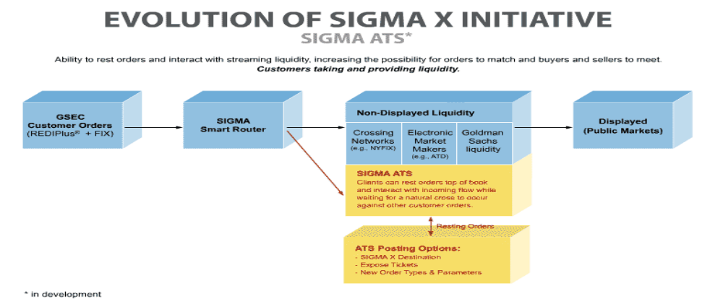

SIGMA X Order Types

Order Type | Required FIX Tags & Values | Explanations
SIGMA Order | 11007=1  100=ExDest | Sweeps orders through the SIGMA-X hidden liquidity pools to improve execution quality before being routed to the public markets.  Any unexecuted portion of the order is posted to the exchange destination (specified in tag 100).  By setting tag 100 =; SIGMA will determine the posting destination.
SIGMA X Directed | 11011=1 100=ExDest | This order type only sweeps through the SIGMA X hidden liquidity pools with the unexecuted portion of the order posted to the specified exchange destination.
SIGMA ATS Order | 100=47  59=0, 3 | Routes orders to SIGMA ATS directly. There orders are matched against other orders in the ATS book as well as orders sweeping through SIGMA-X.  SIGMA ATS is one of the non-displayed liquidity pools in SIGMA-X.
SIGMA X Ping | 11011=1  100=47  59=3 | Order checks for an immediate execution within all of the non-displayed liquidity pools within SIGMA-X. Order will never be routed to the public markets and user gets a urout on the unexecuted portion.

SIGMA X Execution Instructions

Execution Instructions | Required FIX Tags & Values | Description
Peg Primary | 18 = R  100 = 47  54 = 1,2  40 = P | Buy orders will track the NBBO bid price and Sell orders will track the NBBO ask price.  Customer can use Peg market if they want orders to track the NBBO of the opposite side of the market.
Peg Mid | 18 = M  100 = 47  54=1,2  40 = P | Peg Mid allows a user’s order limit to track the NBBO mid price. This order type’s primary usage is to facilitate midpoint crosses.
Peg Market | 18 = P  100 = 47  54 = 1,2  40 = P | Buy orders will track the NBBO ask price and Sell orders will track the NBBO bid price.
Price Limit | 44 = Price Limit  100 = 47  40 = P | Orders will be sent to SIGMA ATS at the specified limit price.  Price limit can be used in conjunction with all peg orders.  *Note - SIGMA-X does not accept market orders.

*Note - Peg Difference tag 211 is optional for Sigma X. Please refer to the FIX Specification v 4.1 for further information.

SIGMA X Modifiers

  ModifiersRequired FIXTags & ValuesDescriptionMinimum SIGMA X Quantity (“MXQ")110Minimum SIGMA X Quantity (MXQ) defines the lowest number of shares an order will ever print for within SIGMA X. If an opposite side order meets a user’s limit price, but does not satisfy the user’s MXQ threshold, the orders will not match. *Note - This attribute is available for all SIGMA X order types. Discretion Offset (Explicit Value) 389=$$.ccAn order with discretion is willing to buy (sell) at a higher (lower) price. It is a value added to buy orders and subtracted from sell orders. Explicit values are in terms of cents to be added/subtracted from the order’s base limit price. Discretion (Relative Value) 11388 Values: 11388=101 Discretion BID 11388=102 Discretion ASK 11388=103 Discretion MID 11388=104 Discretion MIDBID 11388=105 Discretion MIDASK Within SIGMA X relative discretion prices (Bid, Mid, or Ask) are acceptable. Thus, a user’s order could float at an explicit or relative price (ex Peg Bid) and have discretion to another relative price (ex Mid). This will often be used in conjunction with a Minimum Discretion Quantity as a user would be willing to pay up if a significant quantity existed within SIGMA-X. *Note - Discretion Offset (explicit) will override if used in conjunction with Discretion Relative Values.Minimum Discretion Quantity (MDQ)11100Minimum Discretion Quantity (MDQ) defines the minimum number of shares for which a Sigma-X order will utilize its discretion. If an opposite side order is within the price bounds of a user’s discretion, but its quantity does not meet the user’s MDQ, the user’s order will not pay up (or sell down) to facilitate an execution. *Note - MDQ can only be used in conjunction with a SIGMA X order that has a defined discretion. GSCO Liquidity opt out11012=YAllows customers to prevent their orders from interacting with liquidity from the GSCO franchise in SIGMA-X. Orders will interact with all of the hidden liquidity pools in SIGMA-X except for GSCO. *Note - Only available for Sigma Order type.

